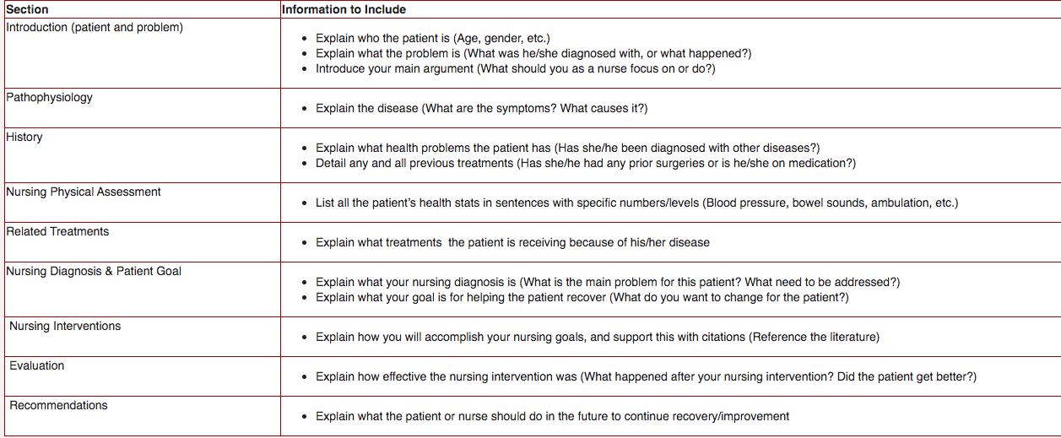

In order to write a case study paper, you must carefully address a number of sections in a specific order with specific information contained in each. The guideline below outlines each of those sections.

Your paper should be 3-4 pages in length and will be graded on how well you complete each of the above sections. You will also be graded on your use of APA style and on your application of nursing journals into the treatments and interventions. For integrating nursing journals, remember the following:
- Make sure to integrate citations into all of your paper
- Support all claims of what the disease is, why it occurs and how to treat it with references to the literature on this disease
- Always use citations for information that you learned from a book or article; if you do not cite it, you are telling your reader that YOU discovered that information (how to treat the disease, etc.)

You can use these links:
https://healthlibraryportal.elsevier.com/?taskContext.c.c=PROBLISTREV&age.v.u=a&age.v.v=27&patientPerson.administrativeGenderCode.c=Female&mainSearchCriteria.v.cs=2.16.840.1.113883.6.3&mainSearchCriteria.v.c=N63.10&mainSearchCriteria.v.dn=Br

24 year old female with 4 month history of small right breast mass. She reports that the mass was increasing in size. Right breast ultrasound 7/6/17 showed 1.4 cm hypoechoic lobulated mass, 6 month follow-up recommended. Ultrasound guided core needle biopsy 7/12/17 showed fibroepithelial lesion with cellular stroma, possible fibroadenoma, rule out phyllodes tumor. Patient takes 25 mg of spironolactone for Acne vulgaris and PCOS

• BP 108/66 (BP Location: Left arm, Patient Position: Sitting, Cuff Size: Adult - Medium) • Pulse 89 • Ht 1.575 m (5' 2") • Wt 58.1 kg (128 lb) • SpO2 98% • BMI 23.41 kg/m2 Physical Exam Physical Exam Constitutional: She is oriented to person, place, and time. She appears well-developed and well-nourished. No distress. HENT: Head: Normocephalic and atraumatic. Nose: Nose normal. Eyes: Conjunctivae are normal. No scleral icterus. Pulmonary/Chest: Effort normal. Right breast exhibits mass. Right breast exhibits no inverted nipple, no nipple discharge, no skin change and no tenderness. Left breast exhibits no inverted nipple, no mass, no nipple discharge, no skin change and no tenderness.

Lymphadenopathy: She has no cervical adenopathy. She has no axillary adenopathy. Right: No supraclavicular adenopathy present. Left: No supraclavicular adenopathy present. Neurological: She is alert and oriented to person, place, and time. Skin: Skin is warm and dry. Psychiatric: She has a normal mood and affect.

Assessment/Plan: Fibroepithelial lesion Palpable right breast mass with core needle biopsy showing fibroepithelial lesion, rule out phyllodes tumor Discussed nature of fibroepithelial lesion, possible fibroadenoma, rule out phyllodes tumor, excision with 1 cm margins to prevent recurrent phyllodes tumor Discussed risk of anesthetic complications, bleeding, infection She agrees to proceed with outpatient right excisional breast biopsy

please remove buffer information like being. war veteran. This is a regular patient. Please add each header i.e. Introduction, Pathophysiology, History, Nursing Physical Assessment, etc. You must focus on the topic. Do NOT add stuff such as PTSD to this paper. THIS MUST BE A PROFESSIONAL ASSESSMENT! Please make it sound less like an English essay and focus more on the NURSING portion of this assignment. In order you must write about: Introduction: 1. Explain who the patient is (Age, gender, etc.) 2, Explain what the problem is (What was he/she diagnosed with, or what happened?) 3. Introduce your main argument (What should you as a nurse focus on or do?)

